PAPER: Pysteps: an open-source Python library for probabilistic precipitation nowcasting (v1.0) (2019)
Pysteps is an open-source and community-driven Python library for probabilistic precipitation nowcasting, that is, very-short-range forecasting (0–6 h)
Provide modular and well-documented framework for researchers interested in developing new methods for nowcasting and stochastic space–time simulation of precipitation
Includes tools for visualizing and postprocessing the nowcasts and methods for deterministic, probabilistic and neighborhood forecast verification
Design Principles:
- Focuses on the representation of the model errors.
- Comparison of different nowcasting algorithms or running multi-model ensemble nowcasts

Formulation of precipitation nowcasting:
Advection/Motion-Field Estimation Implementation:
3 methods:
- A Local Lucas–Kanade method (Lucas and Kanade, 1981; Bouguet, 2001),
- A global variational echo-tracking approach (Laroche and Zawadzki, 1994; Germann and Zawadzki, 2002)
- Spectral approach (DARTS, Ruzanski et al., 2011).
First two methods take 2 inputs and the third takes 9 omput images.
The currently implemented advection method is the backward-in-time semi-Lagrangian scheme described in Germann and Zawadzki (2002), which is robust against numerical diffusion. (Refer Radar-based Nowcasting notes)

Data Transformation:
- Rainfall values don’t follow a normal (bell-shaped) (Gaussian) distribution.
- These values are ‘Bounded at zero’, i.e, No negative rain (Rainfall cannot be less than 0)
  - So, distribution starts at 0 and goes right.
  - Hence, Asymmetric distribution; Skewed to the right!!
- Hence, models must handle Sparsity and Extremes (heavy tails)
- So, data transformation is needed to approximate a normal distribution.
PySteps assumes a log-normal distribution of rain rates by applying the logarithmic transformation that corresponds to logarithmic radar rain rates (units of dBR)
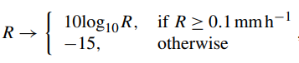R: Transformed rain rates
The value of −15 dBR is equivalent to assigning a rain rate of approximately 0.03 mm h−1 to the zeros

Decomposing Precipitation Field:
The lifetime of precipitation relates to its spatial scale (e.g., Venugopal et al., 1999; Seed, 2003; Germann et al., 2006b), often denominated as dynamic scaling.
Hence, Short-Term Ensemble Prediction System (STEPS) was developed -> PySteps incorporated.
- Decompose the precipitation field into a multiplicative cascade (Refer def from Nowcasting.docx), where the cascade levels represent different spatial scales, and treat them separately in the nowcasting model.
- Without the decomposition, precipitation fields are expected to evolve similarly at all spatial scales following a single AR process.
- In such cases, the lifetime of small-scale (large-scale) precipitation features would be overestimated (underestimated)

Temporal Evolution of Precipitation Fields:
In Nowcasting, approach is “Auto-Regressive”, combining deterministic component from Lagrangian persistence (rain moves according to wind – fixed, not random, hence deterministic) with a stochastic innovation term (random changes we cannot predict), also referred to as a noise or perturbation term (Uncertainty, Variability, and Missing physics).
The combination of the auto-regressive model in time and the cascade model in space allows one to control the temporal evolution and correlation structure of precipitation -> incorporated in PySteps.
Refer to it when implementing Temporal evolution.
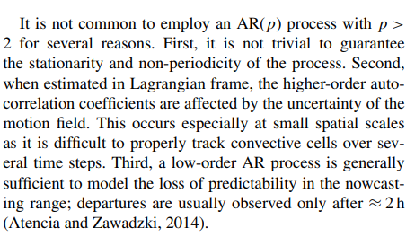

Stochastic perturbations of precipitation intensities:
The perturbation field is typically generated as a correlated Gaussian random field using FFT (Fast Fourier Transformation) filtering using Power-Law. 3 steps:
- generate a Gaussian white noise field,
- apply the FFT and a Fourier filter to the above to generate a random field having the desired correlation structure
- apply the inverse FFT to transform the noise field back to the spatial domain
3 methods for filtering white noise fields have been implemented in pysteps.
- In the absence of a model that predicts the evolution of the spatial correlation structure, one assumes that the correlation structure remains constant through the nowcast. With this rainfall bands cannot be represented.
- Non-Parametric method (allows representation of rainfall bands) -> requires larger sample size
- Noise field is generated locally

Post-Processing of Nowcasts:
To ensure that the forecast fields have the same statistical properties with the observed ones, post-processing is typically done at the very end of the chain.
Steps include tweaking statistical properties such as wet-area ratio, mean, variance and the marginal distribution of precipitation intensities
In PySteps, this involves two types of methods:
- Masking (main one): used to avoid generation of stochastic cells (like random convective cells) into areas that are too distant from existing precipitation.
- Matching the statistics of the forecast fields with the most recently observed ones: can be applied unconditionally or only to pixels within the mask
3 different Masking methods:
- Mask is obtained from pixels exceeding an intensity threshold in the observed precipitation field
- Mask is obtained by using the S-PROG (Spectral Prognosis model by Seed, 2003)
- Leadtime-dependent precipitation mask is applied.

PySteps Library:
Divided into 11 modules, each implementing one subtask. Interchangeable as well.
Data is stored in n-dimensional arrays, which allow an efficient and compact representation.
The output of stochastic nowcasting methods is a four-dimensional array of shape (num_ensemble_members, num_timesteps, height, width). For deterministic nowcasts, the first dimension is dropped.
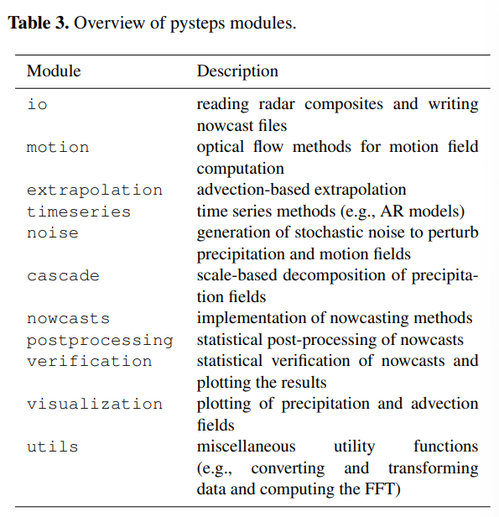
Workflow for generating precipitation nowcasts:
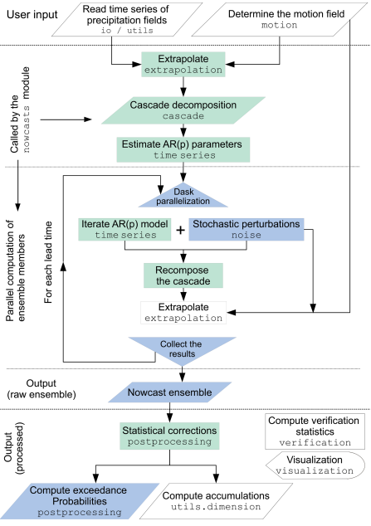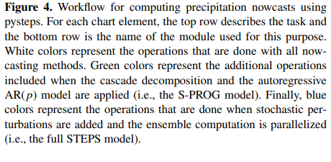
Steps are as follows (can see the module names in the image):
- Read the input data
Conversion from Reflectivity (dBZ) to precipitation intensity (mm h−1 ) and other preprocessing can be done by using the utils module.
- Determine the motion field
The precipitation intensity and motion fields are supplied as inputs to a user-chosen nowcasting method
- Nowcasts.extrapolation has implemented Lagrangian persistence method, so we just generate the nowcast extrapolation.
- When the cascade decomposition and the autoregressive model are used for scale filtering (the S-PROG model), the additional steps include those marked with green color.
- When generating ensembles (the STEPS model), stochastic perturbations are added to the AR(p) models and to the advection field using the methods implemented in the noise module.
  - These steps are marked with blue color
- The ensemble generation is parallelized by using the dask library.
  - For each time step, this is done by splitting the computation to the available processor cores so that each core is responsible for computation of one ensemble member.
- ‘nowcast’ module does all operations involving generating a nowcast, except “Post Processing”. This can be done by:
  - supplying the requested method to the nowcast generator
  - separately by using the functionality implemented in the postprocessing module
The post-processing includes methods to ensure that the nowcasts have the same statistical properties of the observations (see Sect. 2.8), as well as methods for generating different products, such as ensemble mean or exceedance probabilities of given intensity thresholds.
- Computation of accumulations from instantaneous rain rates can be done by using the methods implemented in the utils.dimension module.
- Finally, the nowcasts or nowcast ensembles can be verified and plotted by using the verification and visualization modules, respectively.

EVALUATION OF THE NOWCASTING QUALITY:
Verification is an essential step of nowcasting.
- not only to monitor forecast performance over time but also to provide feedback on how to improve the model itself (diagnostic verification)
For an ensemble forecast, it is necessary to check:
- whether it is unbiased
- has the correct dispersion
- reliable and sharp (e.g., Jolliffe and Stephenson, 2003)
Parameter values used during the experimentation on various radar composites from different countries are as follows:
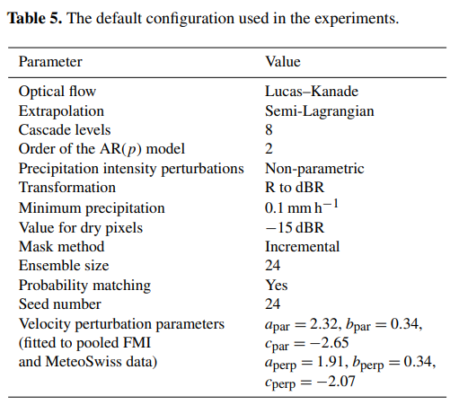
Verification Metrics:
Probabilistic forecasts have been verified using the (but there are others as well which will be listed here from now on)
- Relative operating characteristic (ROC) curve,
- Reliability diagrams
- Rank histograms and Outlier percentages, as implemented in the verification module of pysteps.
ROC Curve:
Measures the ability of a probabilistic forecast to discriminate between precipitation and no precipitation exceeding a given intensity threshold.
- For a set of probability thresholds, the ROC curve is constructed by plotting the probability of detection (POD) against the false alarm rate (POFD), not to be confused with the false alarm ratio (FAR)
- For a perfect forecast, the curve passes through the upper left corner (i.e., 100 % hit rate and 0 % false alarm rate)
- The area under the ROC curve can be used as a measure of potential skill.
- For more details on the contingency tables and the formulas of the categorical scores, the reader is referred to Jolliffe and Stephenson (2003).

Reliability Diagram:
Measures the bias (reliability) and resolution of a probabilistic forecast.
- For a given intensity threshold, the diagram shows the forecast probability against the observed frequencies, where the probability range [0,1] is divided into n bins
- For a perfectly reliable forecast, the curve lies on the diagonal.
- The reliability diagram is often accompanied by a histogram showing the sample size in each bin (sharpness diagram)
  - A sharp forecast has few samples in the middle of the histogram and many on the sides (probability of either 1 or 0).

Rank Histogram:
Measures how well the ensemble spread corresponds to the observed uncertainty
- For each nowcast grid pixel, the ensemble members are ranked in increasing order.
- A pooled histogram is computed by assigning each verifying observation a bin which it falls into among the ensemble members.
  - The first and last bins are assigned for observations below or above all members, respectively
- For a forecast ensemble whose distribution is consistent with the observations, the histogram is flat and no observations fall into the first or last bin.

Outlier Percentage:
Measures the proportion of observations falling outside the ensemble

Fractions skill score (FSS):
This is a standard neighborhood verification method.
FSS measures how well a forecast matches observed rainfall at different spatial scales (grid size). Instead of pixel-by-pixel matching FSS asks “Did the forecast get the rain in roughly the right area?”
Provides an intuitive assessment of the dependency of forecast skill on spatial scale from high-resolution precipitation forecasts (Mittermaier and Roberts, 2010).
- Computed by comparing the forecast and observed fractional coverage of precipitation exceeding certain thresholds in spatial windows (neighborhoods) of increasing size.
  - Example: Choose a rainfall threshold (rain > 1mm). Take a small window (neighborhood) around each point, then compute % of pixel with rain in forecast and % of pixels with rain in obersvations
- Using FSS it is possible to determine how the forecast skill varies with neighborhood size and then determine the smallest scale that provides a sufficiently skillful forecast.
  - Intuition: In a small area, if forecast shows 60% pixels have rain and observation shows 50% pixels have rain, then we compare these fractions and decide to whether increase of decrease neighbourhood size (small -> strict check; exact location, large -> relaxed check; general area).
  - This tells how good the forecast is at different spatial scales; Low score at small scale -> location errors, and High score at larger scale -> got general pattern right
NOTE: An observation that suggests lack of calibration is that the optimal nowcasts for precipitation/no precipitation are obtained by choosing a very low probability threshold (for a well-calibrated nowcast, this would be 0.5).

Critical Success Index (CSI) and Mean Absolute Score (MAE) (Jolliffe and Stephenson (2003))

Numerical Diffusion Analysis: (Refer Review of radar-data nowcasting notes)
In the pysteps method (the extrapolation.semilagrangian module), this is done by iteratively tracing the locations of precipitation parcels and interpolating the intensities only as the final step of the advection (Germann and Zawadzki, 2002).
To verify this advantage, they computed radially averaged Fourier spectra of deterministic nowcasts at various lead times. The analysis is performed using the three optical flow methods to understand whether the semi-Lagrangian scheme is sensitive to quality of the motion field.
Found a perfect overlap of the forecast and observed spectra, an indication that the numerical diffusion of the semi-Lagrangian scheme is very low.

Spatial Structure Analysis:
The aim of probabilistic nowcasting is to generate a reliable ensemble of equiprobable realizations of precipitation fields characterized by power spectra
- Despite a small loss of power for scales, all spectra should be close to observations.
- The spatial structure of ensemble members remains realistic at all forecast lead times.
For the ensemble mean forecast (the avg of ensemble members), the process should produce precipitation fields that become smoother with lead time, which is the aftermath of the loss of predictability at small scales
Observation: one may argue that if the ensemble is too small to model the loss of predictability at such scales, it may also be too small to reliably model the forecast uncertainty.
An alternative way to deterministically represent the forecast uncertainty is to filter out the unpredictable features using the S-PROG model
Read more when you are doing!!

Temporal structure analysis:
Just read it when implementing. Too complex for now (lol)
Auto-correlation function (ACF) is compared.

SENSITIVITY ANALYSIS (and Computation Demand):
Analyse the sensitivity of pystreps to its configuration options and parameters such as the optical flow method, the ensemble size, the parameter localization and the cascade decomposition.

Optical Flow and Scale Filtering:
Determination of the advection field by optical flow is a key component of any extrapolation-based nowcasting system.
We know there are three methods (see above).
- It is observed that applying Scale Filtering (implemented in S-PROG) improves both CSI and MAE scores, at longer lead times.
Measure the computation times of different optical flow methods!!
NOTE: In the paper, the experiments were done using an Intel Xeon E5645 CPU with 12 cores running at 2.4 GHz with parallelization enabled in the optical flow methods.
- It is observed that DARTS (Fourier space) and Lucas-Kanade (Local) Optical flow method have significantly lower computational requirements than variational methods (VET),
The choice of optical flow method plays a significant role as per observations. More focus should be on nowcast errors due to dynamic scaling properties of precipitation, which will arise due to scale filtering on the forecast skill

Ensemble Size:
The ensemble size is one of the main factors contributing to the quality and computation time of pysteps nowcasts. There will be a trade-off.
To get optimal number for ensemble size, evaluate using ROC and Outlier Percentage (OP)
Unlike optical flow method choice, the choice of Ensemble size matter a lot!!, particularly true when nowcasts of higher precipitation intensities are desired
Using ROC Analysis (they should be close to 1, so play around with n size)
- Paper suggests that size of 24 members are sufficient when nowcasts of precipitation/no precipitation are desired with low-intensity thresholds (e.g., 0.1 mm h−1 )
- When threshold is increased to 5 mm h−1, increasing n from 48 to 96 or 100+, significant improvement can be expected.
Using OP Analysis, (highly dependent on Ensemble size)
- It is observed that “With 96 ensemble members, OP is below 15 % after 20 min, which indicates that the ensembles are well able to capture the uncertainties in the spatiotemporal evolution of precipitation.”
- OP can be further reduced by increasing the ensemble size over 100.
- There is a significant dependence of OP on the lead time.
  - The highest OP was observed at 20 min, and after 3 h it is up to 50 % smaller
For computational time analysis of generating nowcast ensembles,( In a real-time setting, it is essential to know how many ensemble members can be produced before the arrival of the next input radar rainfall image (usually every 5 min))
- 1 h nowcasts were computed with different ensemble sizes and number of parallel threads.
- It was observed that “it is possible to generate 1 h nowcast ensembles of up to 48 members in less than 2 min using a server with 12 processor cores.”
- “the computation time decreases approximately linearly with respect to the number of threads (i.e., the computation time is halved when the number of threads is multiplied by 2)”

Localization:
Localization means restricting the nowcasting model into small subdomains instead of applying it the whole domain assuming spatial homogeneity (refer Nowcasting.docx def) of the precipitation field.
It is applied to the
- cascade decomposition
- the autoregressive process
- the non-parametric Fourier filter
- the probability matching
Impact is assessed in terms of rank histograms and reliability diagrams (threshold of 1.0 mm h−1 ) for a 30 min lead time
“The localization should show positive effects in the ensemble spread, improving both in terms of reliability and conditional bias, although you can also observe a slight decrease of sharpness.”
- Rank histograms tend to get flatter as the localization window gets smaller.

Cascade Decomposition:
Designed to account for dynamic scaling.
Dynamic scaling properties are necessary to produce a realistic temporal evolution (lifetime) of precipitation across spatial scales.
- this would give correct ensemble dispersion
To test this,
Compare the stochastic nowcasts with and without the cascade decomposition to analyse the realism of the temporal evolution (refer the paper)
- Observed that model with eight cascade levels reproduces well the dynamic scaling properties, especially at small wavelengths.
- To stop overestimation of the lifetime at larger wavelengths, we have to adjust the AR parameters
- Model without cascade decomposition overestimates the lifetime at smaller wavelengths.

TESTING/ Results:
- Tropical cyclone nowcasts preserve the original cyclonic pattern up to 60 min ahead but some distortions are induced for longer lead times due to convergence and divergence.
- Additional data sources such as satellite or NWP forecasts may help to estimate future advection velocities and reduce potential anomalies for longer lead times.

